HEALTHCARE PROVIDER TOOLKIT
ADHERENCE
What is Adherence and how is it Different from Compliance? A Team Approach to Establishing COPD Treatment Goals
The World Health Organization defines adherence as “the extent to which a person’s behavior, in terms of medications, following diets, or executing lifestyle changes corresponds with agreed recommendations from a health care provider.”1 In recent years, the term adherence has replaced the term compliance because of increasing recognition that engagement in the management of one’s disease is a partnership between the patient and the medical team, whereas compliance infers that a patient must follow “the doctor’s orders.”
How to Assess Adherence to Medical Treatment Regimens
I have often heard family members, medical students, and even providers say that patients “should just do what they need to do to manage their disease.” This is nice in theory; however, decades of research and clinical practice have shown that many patients are unable or unwilling to adhere to their treatment regimens. Learn more about the "Do's" and "Don'ts" of adherence conversations.
ALPHA-1
The Latest Alpha-1 Clinical Practice Guidelines
Dr. Robert Sandhaus, co-author of the latest Alpha-1 Antitrypsin Deficiency Clinical Practice Guidelines, describes differences between the newest and former guidelines, their importance for those in primary care settings as well as the current and future Alpha-1 Antitrypsin Deficiency research landscape.
CASE STUDIES & ARTICLES
Barnes Jewish Hospital
Debbie Bennett, RRT, BS, supervisor of Pulmonary Rehabilitation at Barnes Jewish Hospital, fills us in on their quality improvement initiative to improve education for their COPD patients.
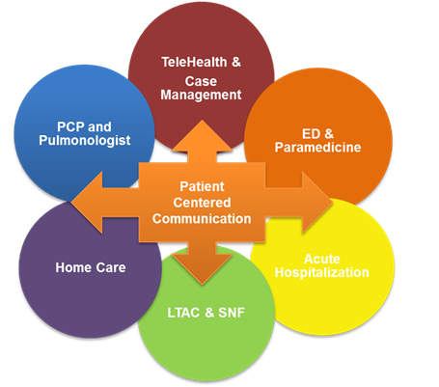
Carolinas HealthCare System
Carolinas HealthCare System (CHS) is one of the leading healthcare organizations in the Southeast U.S. and one of the most comprehensive not-for-profit systems in the country. Dr. Dan Howard, Medical Director of the Respiratory service line and Dr. Amy Clary, Assistant Vice President of the CHS Medical Group, gave us a peek into their successful COPD care and readmissions reduction program.
& CHS profiled in Healthcare IT News.

Changing Outcomes in COPD through Motivational Interviewing

Dr. Roberto Benzo, clinician, pulmonologist, and behavioral researcher at Mayo Clinic, shares his work in motivational interviewing with COPD patients. Learn more about this guiding style that engages people on the issues that matter most to them on the path to behavior change.
Care Innovation via Transportation
From AHRQ, a collection of articles on the use of EMS and emergency transport to proactively improve care.
Cone Health
Learn more about Cone Health's gold-star program for people with COPD -- and how it translates to improved health outcomes for their patients.
Effectiveness of Interventions to Teach Metered-Dose and Diskus Inhaler Techniques
This was a randomized study that compared inhaler retention and health care utilization after receiving in-person teach-to-goal (cycles of demonstration and assessment) or brief verbal instructions (BI) for teaching inhaler technique among hospitalized patients with asthma or COPD. While TTG was again superior to BI immediately post hospital-based education, skills waned within 30 days. However, health care utilization was significantly lower among the TTG vs the BI cohort within 30 days post-discharge; this difference was not present at 3 months. These data indicate that teaching inhaler technique with TTG to hospitalized patients can impact health outcomes, while also showing that repeated education is necessary for longer term skill retention and positive health outcomes.
Effects of a post-discharge COPD clinic on readmissions among veterans with COPD exacerbations
Chronic obstructive pulmonary disease (COPD) results in 700,000 hospitalizations per year, with about 20% of patients readmitted within 30 days. The objective of this report is to summarize readmission rates before and after the implementation of a post-discharge COPD clinic at a veteran’s affairs hospital.

House call program helps COPD patients reduce hospital visits

As part of Via Christi’s house call program, healthcare providers monitor wellness and troubleshoot obstacles through regular visits to COPD patient’s homes. They are supported by a care team of APRNs, social workers and others. Patients enrolled in the program can reach support by phone 24 hours a day and can also attend virtual appointments with their healthcare providers.

Misuse of Respiratory Inhalers in Hospitalized Patients with Asthma or COPD
This study evaluated inhaler technique among 100 patients hospitalized patients with asthma or COPD and found that 86% of patients misused their rescue inhaler and 71% misused a common controller device. This patient population was high risk with over 80% having been hospitalized within the prior year for their asthma or COPD at least one time (not counting the current admission) and two-thirds having had a near fatal event in their lifetime defined as an ICU admission and/or need for intubation.
Pittsburgh Regional Health
Learn how the Pittsburgh Regional Health Initiative (PRHI) is tackling COPD and avoidable readmissions in western Pennsylvania through improved inter-disciplinary care coordination, attention to comorbidities and an ever-evolving and participatory quality improvement process. PRHI's COPD readmission rates are down 20.4%.
Prevalence of Low Peak Inspiratory Flow Rate at Discharge in Patients Hospitalized for COPD Exacerbation
From abstract: Low peak inspiratory flow rate (PIFR) (<60 L/min) among patients with chronic obstructive pulmonary disease (COPD) may result in ineffective medication inhalation, leading to poor bronchodilation. The objectives of this analysis were to evaluate the prevalence of low PIFR at the time of discharge from a COPD-related hospitalization and to examine the real-world treatment patterns and rehospitalizations by PIFR.”
Preventing COPD Readmissions
Utilizing non-invasive ventilation and comprehensive follow-up care in patients' homes to help ensure they stay there.
Rethinking Hospital Admissions
From NPR’s Marketplace, a report highlighting a facet of care that helped reduce readmissions for one Philadelphia COPD patient.
Rutland Regional Medical Center
Since program inception, when the COPD readmissions rate was 20%, rates have steadily decreased; Rutland Regional reports 2015 readmissions rates at 5.4%.
The Effects of a Comprehensive Care Management Program on Readmission Rates After Acute Exacerbation of COPD at a Community-Based Academic Hospital
Select text from abstract: Acute exacerbation of chronic obstructive pulmonary disease (AECOPD) is one of the leading causes of hospitalization in the United States. Prior investigations suggest clinical and physiological parameters are important determinants for AECOPD readmissions. Strategies aimed at addressing these factors have not resulted in a major reduction of readmissions. We compared patients readmitted after an index AECOPD admission with non-readmitted patients. Patients’ age, gender, body mass index, comorbidities (obstructive sleep apnea, chronic hypercapnia, congestive heart failure, lung cancer, pulmonary arterial hypertension, pneumonia, interstitial lung disease, atrial fibrillation, musculoskeletal disorders, cognitive disorders, and anxiety disorders), substance abuse and smoking status were assessed.
Implementation of a comprehensive care management program (CCMP) was associated with a reduction in readmissions from 21.5% to 13.6% (p<0.01, 95% confidence interval [CI] 2.08-12.45). A CCMP can reduce readmissions through attention to social variables, optimization of in-hospital care, improved coordination of pre- and post-discharge, a system to better identify problems after discharge, and an office setup that accommodates same-day visits.
Teaching the Use of Respiratory Inhalers to Hospitalized Patients with Asthma or COPD: a Randomized Trial
This was a randomized study that compared initial inhaler technique skills after education using in-person teach-to-goal (cycles of demonstration and assessment; TTG) to brief verbal instructions (BI) among hospitalized patients with asthma or COPD. Within each cohort, inhaler misuse was reduced for rescue inhalers, however the TTG had a significantly lower likelihood of misusing rescue devices than the BI cohort. TTG was also more effective than BI for decreasing misuse with Diskus devices.
The Hospital-Dependent Patient
In this New England Journal of Medicine Perspectives piece, Drs. David Reuben and Mary Tinetti explore the concept of the “hospital-dependent patient.” “These patients' readmissions are counted in readmission rates, and their cases may erroneously be considered to represent failures of the transition process. However, the underlying causes of these readmissions are not failed transitions and the approaches to their management must be tailored accordingly.”
Unique Team Helps this COPD Readmissions Reduction Program Get Positive Outcomes
At the Baylor Scott & White Medical Center in Plano, Texas, preventing COPD readmissions begins on the day an individual is brought into the hospital. Their approach involves a coordination of care among physicians, nurses, pharmacists, respiratory therapists and even students to ensure that all of the patient's needs are addressed. More importantly, each member of the team understands every member's role and how they all contribute to the process.

COPD FOUNDATION RESOURCES

PROVIDER RESOURCES
The COPD PRAXIS is the COPD Foundation’s (COPDF’s) one-stop shop for healthcare providers.

Main menu: www.COPDFoundation.org/PRAXIS
Some of the community’s features include:
- A searchable Resource Repository filled with more than 180 best practices, research articles and toolkits designed to improve COPD care across the continuum.

- The PRAXIS Nexus blog, highlighting promising practices, your colleagues in the field and breaking policy news.

The Foundation also publishes a peer-reviewed, open-access journal each quarter. Chronic Obstructive Pulmonary Diseases: Journal of the COPD Foundation is dedicated to publishing free original research, reviews, and communications related to COPD.

Check out the free COPD Pocket Consultant Guide a summary of diagnosis and treatment guidelines packaged in a simple, convenient and portable guide. Download the free app here! (An update to this iOS app – as well as an Android version – will be available in Fall 2018.)

PATIENT RESOURCES

The Foundation also has extensive resources for your patients at www.copdfoundation.org.

Educational materials for patients and caregivers can be found at www.COPDFoundation.org under the “Learn More” menu, covering topics from pursed-lip breathing to pulmonary rehabilitation.

Patients and families can join our active, free online social hub COPD360Social! The community now has more than 36,000 members. Those with Bronchiectasis or NTM now have a dedicated site and social community at https://www.bronchiectasisandntminitiative.org/.

The C.O.P.D. Information Line – 1-866-316-COPD (2673) – staffed by individuals with COPD and caregivers, is available toll free weekdays from 9 am to 6 pm ET. The line provides one-on-one, peer-to-peer educational, social, coaching, resource and emotional support.
Tip: Add the link to our social sites and number for the C.O.P.D. Information Line to your discharge instructions.

Two of our favorite resources for patients & providers: the COPD Action plan and our series of online inhaler instruction videos – take a look!

The COPD Foundation is proud to offer Harmonicas for Health, the first nationwide harmonica program created especially for individuals with COPD and other chronic lung diseases. Learn more here!

We have a variety of research initiatives open for possible participation:

- COPD Patient-Powered Research Network – a research registry of individuals with COPD who have agreed to share their health information and the impact the disease has on their lives.
- The Bronchiectasis and NTM Research Registry – a consolidated database of non-Cystic Fibrosis (non-CF) Bronchiectasis and/or NTM patients from multiple clinical institutions across the United States.
- The O₂VERLAP study is designed to test the effectiveness of web-based education and coaching methods on improving adherence to CPAP therapy for patients living with COPD and obstructive sleep apnea (the combination of these diagnosis is referred to as Overlap Syndrome). The study provides free online lessons to individuals living with COPD and OSA who require the use of CPAP at night. We’ll monitor whether and how it improves patients’ adherence to their CPAP prescription and ultimately, how it improves their health.

GENERAL READINGS
Patient-centered care
What is patient-centered care? And how do we ensure that as hospitals and individual healthcare providers that patient-centered care is our default approach?
Patient- and Family-Centered Care: It’s Not Just for Pediatrics Anymore
Advancing the Practice of Patient- and Family-centered Care in Hospitals
Evidence-based medicine
Evidence-based medicine is not universally employed in COPD care. For example, according to the National Committee for Quality Assurance (NCQA), only 36 percent of Medicare patients diagnosed with COPD have had the diagnosis confirmed through spirometry. But what exactly is evidence-based medicine? And why is it important?
What is evidence-based medicine and why should I care?
(download free pdf at above link)
Health Disparities & Cultural Competence
Research has shown that lower socioeconomic status is associated with increased burden of COPD and poorer health outcomes. What are these inequities and how can we acknowledge and address them? What does it mean to approach patients and chronic disease in a culturally competent way?
Defining and targeting health disparities in chronic obstructive pulmonary disease
Cultural Competence in Health Care: Is it Important for People with Chronic Conditions?
Health Literacy
Learn more about how low health literacy can impact COPD patients' health care experiences, including their adherence to medication and device regimens. What can we do to gauge the health literacy of our patients and ensure we are meeting their needs?
Health Literacy in COPD
8 Ways to Improve Health Literacy
PARTNERSHIPS
Building a Bridge with Post-Acute Providers (article starts on page 24)
From ACMAweb.org, an article on the importance of establishing and logistics of maintaining strong relationships with post-acute providers.
HRET's guide to building effective partnerships
One of the themes common to those most successful in COPD care delivery is the development and nurturing of community partnerships. Health care organizations heighten their impact and extend their reach when they work closely with fellow health care organizations, faith-based groups, transportation companies, businesses and other invested stakeholders.

PUBLIC POLICY
The COPD National Action Plan
Through a collaborative national effort by the COPD community, the National Institutes of Health (NIH) and partners including the COPD Foundation developed the COPD National Action Plan. This first-of-its-kind Action Plan provides a unified framework to guide stakeholders nationwide in their efforts to reduce the burden of the disease.
Broken into five goals with specific focuses, each goal of the Action Plan covers the entire spectrum of complex issues related to COPD, including the needs of patients and the greater public, health care delivery and practice guidelines, research potential, and policy implications.
The five goals are:
- Goal 1: Empower patients, their families, and caregivers to recognize and reduce the burden of COPD
- Goal 2: Equip health care professionals to provide comprehensive care to people with COPD
- Goal 3: Collect, analyze, report, and disseminate COPD data
- Goal 4: Increase and sustain COPD research
- Goal 5: Turn COPD recommendations into research and public health care actions
The Action Plan serves as a cohesive tool for stakeholders to use in driving change and supporting activities to change the trajectory of the disease. Everyone in the COPD community has an important role to play in the success of the COPD National Action Plan. To learn more about the Action Plan and to download a free copy of the plan, the COPD National Action Plan At-a-Glance, a PowerPoint presentation and fact sheet, visit https://www.nhlbi.nih.gov/health-topics/education-and-awareness/COPD-national-action-plan.
SMOKING CESSATION
Freedom From Smoking
The American Lung Association's (ALA’s) Freedom From Smoking® program is for individuals who are ready to quit smoking. Because most people know that smoking is dangerous to their health, the program focuses almost exclusively on how to quit, not why to quit. Resources available at this link include Freedom From Smoking Plus, which is accessible via desktop, tablet or smartphone; Freedom From Smoking group clinics; and the ALA’s Lung Helpline (1-800-LUNGUSA).
TOOLS & READMISSIONS TOOLKITS
Case Management Adherence Guidelines for COPD
This Case Management Society of America (CMSA) toolkit provides guidance for front-line healthcare providers on patient-centered diagnosis and treatment adherence recommendations for their COPD patients. The tool covers care across the continuum, from defining and diagnosing COPD to adherence tools and challenges, case management approaches within different settings to successful discharge and follow up.
Fundamentals of Reducing Acute Care Hospitalizations
This toolkit of resources was developed by the Home Health Quality Improvement National Campaign for use by home health care providers and other healthcare audiences seeking best practices in the management of disease with an eye toward reducing unnecessary readmissions. A main introductory package is included for health systems leadership as well as for specific disciplines, including nursing and therapy. Additional resources include an overview webinar, podcast and presentation slides; case studies and success stories; and patient awareness, education and empowerment materials. A "COPD Zone Tool" is included in both English and Spanish for patients, caregivers and healthcare providers to communicate patient status consistently using green, yellow and red status descriptions. Free registration required.
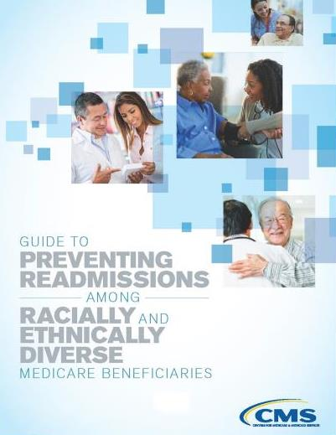
Guide to Preventing Readmissions among Racially and Ethnically Diverse Medicare Beneficiaries
The Centers for Medicare & Medicaid Services have released a new publication on preventing readmissions in diverse populations. As minority populations have been shown to be more likely to be readmitted within 30 days of discharge and as health care systems now care for a growing racially and ethnically diverse patient groups, the authors note that attending to issues specific to these populations is of the utmost importance.
Improving Care Transitions between Hospital and Home Health: A Home Health Model of Care Transitions
This 71-page PDF outlines the Alliance for Home Health Quality and Innovation home health model for care transitions from hospital to home. The document includes an overview of the model; transitional care checklists to ensure essential elements are covered at important time points (e.g., patient education prior to hospital discharge); key components for care transitions tools (e.g., medication lists); transitional care guidance and guidelines; evidence-based tools; and patient resources.
ISMP's Guidelines for Standard Order Sets
The Institute for Safe Medication Practices Guidelines for Standard Order Sets has been developed to help organizations ensure that the elements of safe order communication have been followed when designing paper-based or electronic order sets. The guidelines focus primarily on medication orders within order sets but also cover general aspects related to the design, approval, and maintenance of all standard order sets.
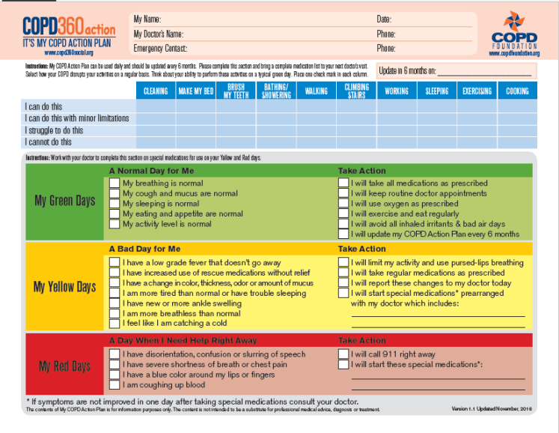
My COPD Action Plan
Research has shown that clear action plans may improve health outcomes for people with COPD. One 2011 study showed that adherence to an action plan was associated with more prompt treatment and therefore a reduced exacerbation recovery time; a 2009 study revealed that those employing a COPD action plan as part of their care were significantly less likely to require hospitalization than were their standard of care counterparts. The COPD Foundation created the My COPD Action Plan to be used by patients daily; it should be updated at least every six months. We encourage COPD patients to discuss these regularly with their care team and use the action plan to recognize and act on the signs of an approaching exacerbation.
My Quality Improvement (MyQI) Guide on Readmissions
This AHRQ toolkit includes: 1) general resources on readmissions reduction programs, 2) case studies and lessons learned, 3) promising practices, 4) resources on care coordination, including medication reconciliation, discharge planning and care transition tools and 5) resources for improving patient communication and education. The toolkit houses a variety of types of resources, including reports, research, websites and checklists.
NCAL Hospital Readmissions Resources
This National Center for Assisted Living (NCAL) resource page includes websites, guides and webinars on a variety of topics related to reducing preventable readmissions, including improving provider communication as well as transitions of care involving long-term care facilities and effecting culture change toward person-centered care.
North Carolina Quality Center Reducing Readmissions – Resources
This extensive online list includes a variety of readmissions reduction resources, including presentations, webinars, tools, tips and guidebooks. The main readmissions reduction toolkit includes 1) a project charter, including timeline, 2) a data manual, 3) a project plan with accompanying instructions for adapting this to your own institution, 4) a change package to guide implementation of these new approaches and 5) tools to create and maintain the newly implemented approach.
NTOCC Health Care Professionals Tools and Resources
The National Transitions of Care Coalition has compiled this group of resources devoted to identifying gaps in and improving transitions of care. Included are tools for distribution to patients, transitions of care guidance and measures, cultural competency materials, a paper on the role of information technology in improving care transitions, specifications for the essential elements of medication reconciliation, and policy and issue briefs. This collection holds resources for health care professionals, health systems administrators and policy makers.
Risk Assessment - 8P’S (Project BOOST)
This Society of Hospital Medicine tool outlines eight factors the Project BOOST team recommends should be documented and analyzed for each patient as part of a structured risk assessment. These include problems with medications, palliative care and principal diagnosis (including COPD). The authors recommend pairing each of the 8 P's with an appropriate intervention available at the user's institution; assigning each of the P's to an individual or role to maintain accountability in implementation; engaging patients and families in the risk assessment and amelioration process; and ensuring the outcomes for assessed variables are communicated to all involved providers.
Particular resources of note in the SHM COPD Implementation Toolkit include:
- An example process map documenting participants, key treatments and decisions at each phase of hospitalization (p 14-15);
- Guidelines for developing and implementing a medication reconciliation process (p 79-82);
- Resource tables for health literacy (p 89-90) as well as patient education and self-management (p 93-95) and device education (p 96-97);
- A draft COPD order set (p 127-129).
Root Cause Analysis Tool: Patient Interview Questions
This 22-question COPD Foundation tool assists front-line COPD healthcare providers in root cause analysis to gauge the contributions of certain factors (e.g., medication, support at home) to an individual patient's hospital readmission. A supporting article can be found here.

Society of Hospital Medicine (SHM) COPD Implementation Toolkit
This 180-page Society of Hospital Medicine (SHM) toolkit is designed to help clinicians, medical directors and healthcare administrators to improve the care of patients who are hospitalized for an exacerbation of chronic obstructive pulmonary disease (COPD). The guide devotes sections to implementing and sustaining a quality improvement project; best front-line care practices, including promising practices in organizing care teams, risk assessment, pharmacologic and non-pharmacologic therapies, ventilation and comorbidities; as well as developing, implementing and evaluating interventions. SHM also has a robust Post-Acute Care Transitions Toolkit, which can be found here.
The Care Transitions Program

This University of Colorado Denver program is designed to improve care transitions through the use of a transitions coach trained to provide self-management patient and caregiver education via home visits and phone calls. This site details the program, cites key effectiveness findings and case studies, and includes a list of free downloadable program tools. Note that training for program implementation is fee-based and offered in combination web and in-person sessions. In 2014, the New York Times devoted a The New Old Age blog post to this program and its impacts.
UC Davis Health System ROADTM Center Acute Exacerbation of COPD (AECOPD) Algorithm
Part of this algorithm is the UC Davis ABCDEF checklist tool. The ABCDEF checklist tool can help to reduce COPD symptoms and risks related to COPD. It was created to give both patients and providers an idea of what to expect together in the first step towards a better life living with COPD. It promotes patient safety by informing patients of the many resources (education, exercise, pharmacotherapy aimed to maximize lung function, and if indicated, to reduce AECOPD). When patients understand HOW and WHY they are being treated or routed to certain patient care services, they become more intrinsically motivated to participate in their COPD care. Patients are held to a higher level of understanding and commitment to a COPD Action Plan and physicians and providers are held to a higher level of service and management that will promote patient safety.
Outcomes in the ROAD program at UC Davis: a reduction in hospital readmissions that has been sustained below 7% for more than 3 consecutive years.

